As we can see in the above donut chart that the total donut has been divided into various seasons. Season wise percentage of total riders has been shown above. The above analysis would be helpful for increasing the count of member-type riders, which is the main requirement of this project.

Below is the total number of riders found after analysis of given data of 12 months.

|  |  |  |
| --- | --- | --- |
| **Season** | **Total** | **Percentage** |
| Fall | 1184979 | 28% |
| Spring | 970213 | 23% |
| Summer | 1619957 | 38% |
| Winter | 465627 | 11% |

As we can see total number of riders during Summer is maximum(1619957) while total number of riders during winter is minimum(465627).

So, Summer season would be the best season for increasing the members or riders.

In the above bar chart, the X-Axis represents each session of a day which is Morning, Afternoon, Evening and Night. Session wise total riders has been shown above. Most preferred and least preferred session of the day shows the session in which total number of riders is maximum and minimum.

Below is the total number of riders found after analysis of given data of 12 months.

|  |  |
| --- | --- |
| **Time of the day** | **Total** |
| Morning | 1118238 |
| Afternoon | 1916651 |
| Evening | 1067856 |
|  |  |
| Night | 138031 |

This analysis can be used to know the session in which promotions can be offered to improve count of riders.

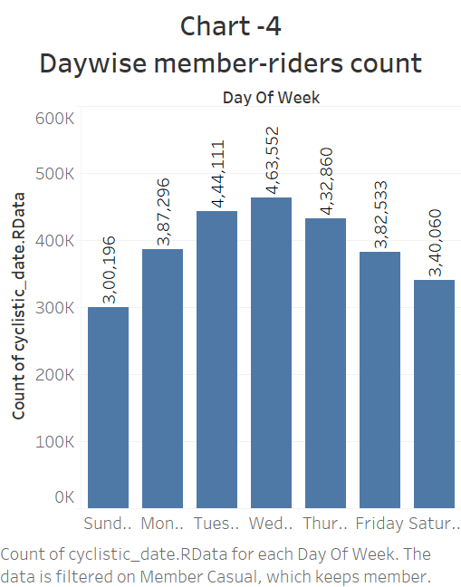

The above bar chart shows the total number of member riders day-wise , the X-Axis represents each day of the week. Day wise total number of member-riders has been shown above. The maximum number of total member riders is on Wednesday. So, the casual riders can be converted to member riders by giving some special offers on Wednesday so that they could be tempted to become member riders.

The above pie-chart represents the popularity of type of bike by showing percentage of riders preferring the type of bike .As Classic Bike has maximum percentage of riders ,so the number of classic bikes can be increased to get more riders.

The above bar-graph shows the top 5 starting stations where the count of casual riders is maximum. This count can be converted to member riders by promoting more tempting offers at those stations.